CS560 Knowledge Discovery and Management

Feb. 28 (fri), 2014

**LAB - 4**

**Report on Mahout Implementation using Recommendation and restful webservice**

**BY**

**SIVA KRISHNA KOMMINENI**

**16104984(sk7x9)**

**Task 1:** **Cloudera/Mahout/Solr**: Implementation of Mahout application , Recommendation and storing output to solr.

Create a maven project and then prepare your own data and then run the recommender algorithm using the commands and make the changes in pom.xml.

Then compile the code for recommendation using the mvn compile .

We will get the output as follows.

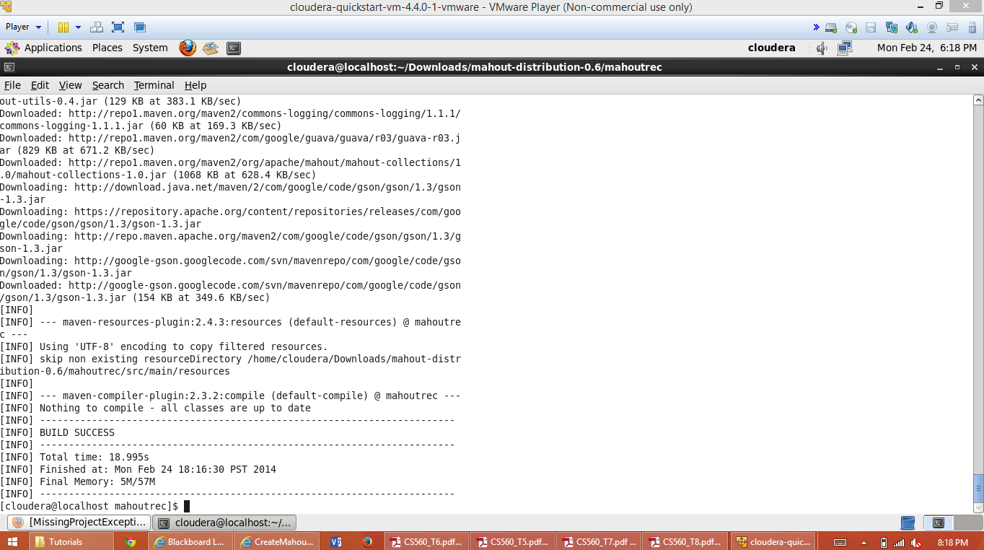

Then execute the maven using final execution steps which generates final output using the recommendation algorithm.

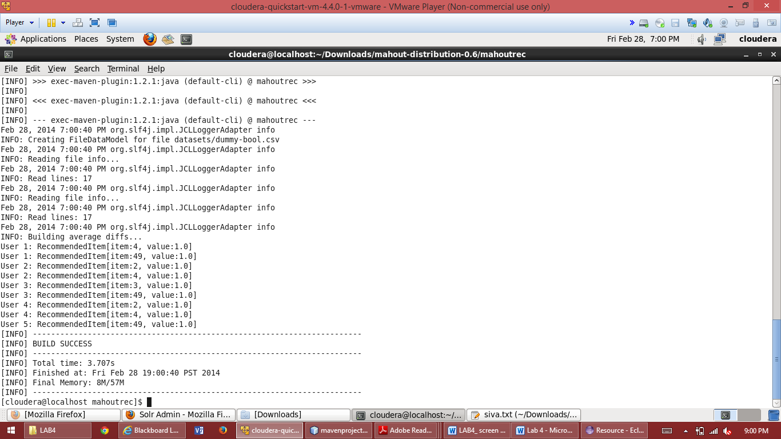

This shows the recommended items for the particular item to the concerned user.

Then connect to the Solr using and push the data manually then we can get the given input in as follows.

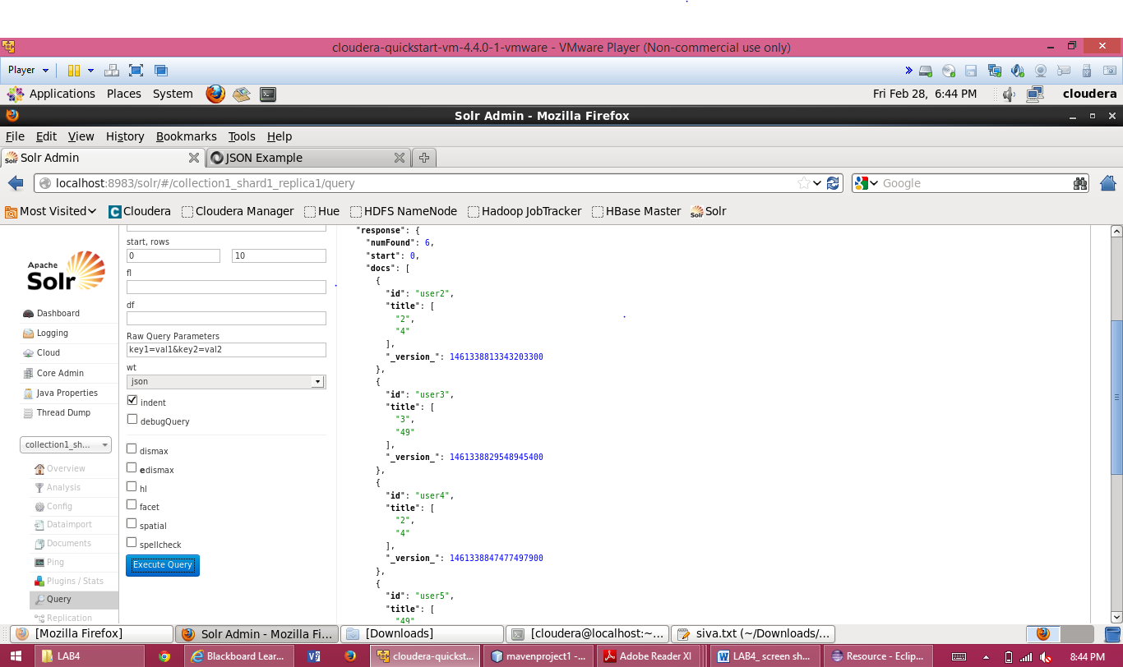

Finally by using query we get the final output as follows. This generates the output in Solr.

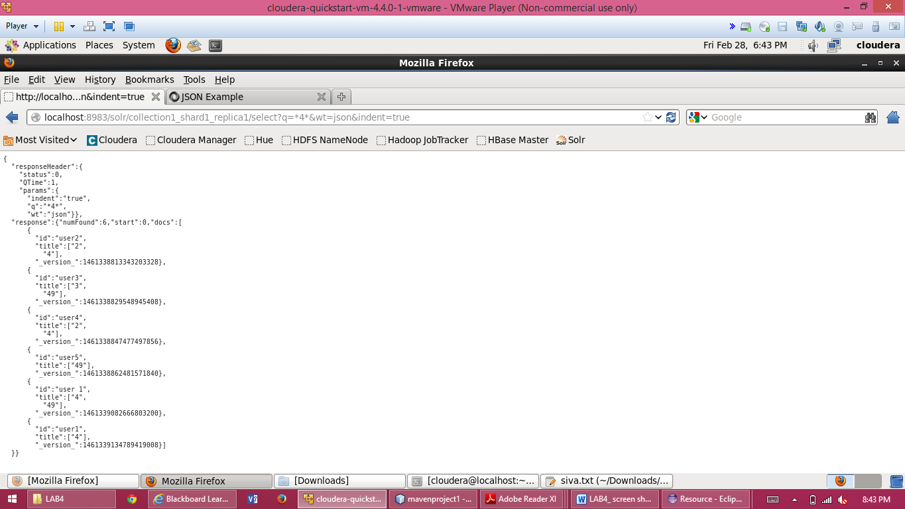

**Task 2:** **Mobile Application**: Implementation of mobile application to use the information through Solr REST Web Services.

A restful service using the Solr data is created and the output is obtained as follows.

This is the json output available in the console.

{"responseHeader":{"status":0,"QTime":1,"params":{"q":"*4*","wt":"json"}},"response":{"numFound":6,"start":0,"docs":[{"id":"user2","title":["2","4"],"_version_":1461338813343203328},{"id":"user3","title":["3","49"],"_version_":1461338829548945408},{"id":"user4","title":["2","4"],"_version_":1461338847477497856},{"id":"user5","title":["49"],"_version_":1461338862481571840},{"id":"user 1","title":["4","49"],"_version_":1461339082666803200},{"id":"user1","title":["4"],"_version_":1461339134789419008}]}}

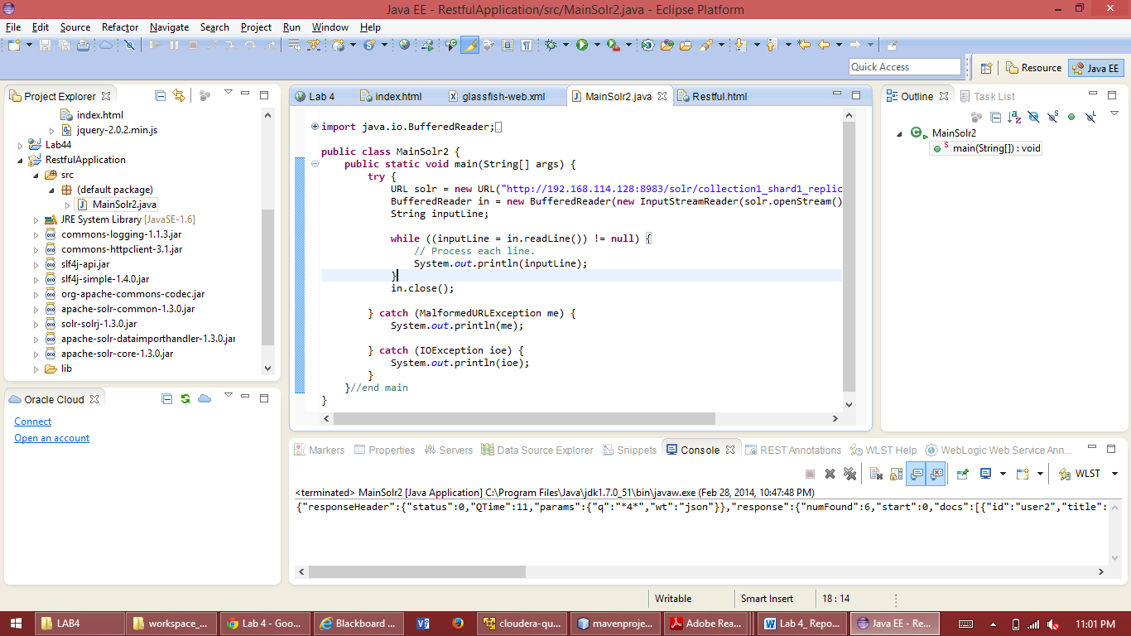

Then it shows the recommended items to the users as follows by using the html file associated with it.

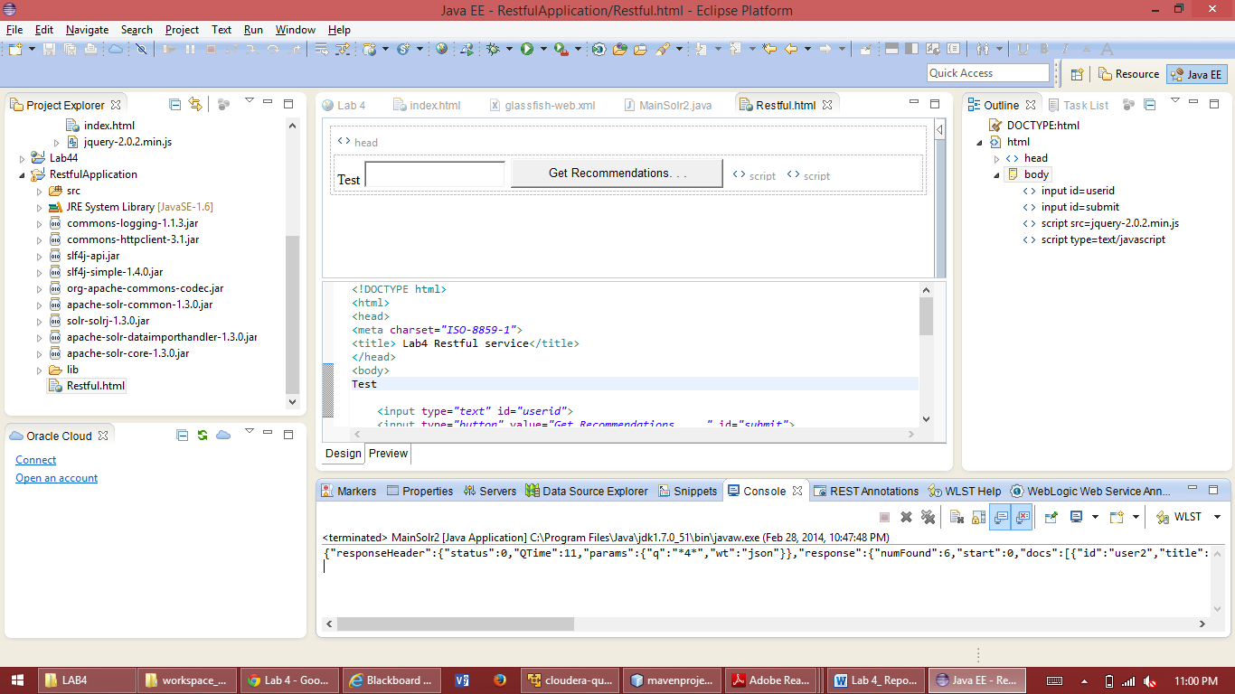

When clicked on get recommendations by selecting the item we get the item recommended to the user.

**Url** to acess the json data is –

http://192.168.114.128:8983/solr/collection1_shard1_replica1/select?q=*4*&wt=json

**Task 3:** Report is enclosed with screen shots.

**Task 4:** Source code and github link is posted.